1. If your CAWP Pane does not contain the columns **Control Account.CA Number, Control Account.Reporting WBS,** and **Work Package.SWBS**, you will need to add them. Open your program in Cobra and expand all. With your cursor in the column header on the CAWP Pane, right-click and select **Insert Column**. Click the dropdown for Field Name and select **Control Account Code 2** (Control Account.CA Number). Click the dropdown again and select **Control Account Code 3** (Control Account.Reporting WBS). Click the dropdown again and select **Work Package Code 4** (Work Package.SWBS).
2. Copy the CAWP Pane. Edit>Copy CAWP Pane. Navigate to and open the file. Delete all columns except **WBS, OBS, WP, Control Account.CA Number, Control Account.Reporting WBS, and Work Package.SWBS**
3. Your file should be formatted like this:

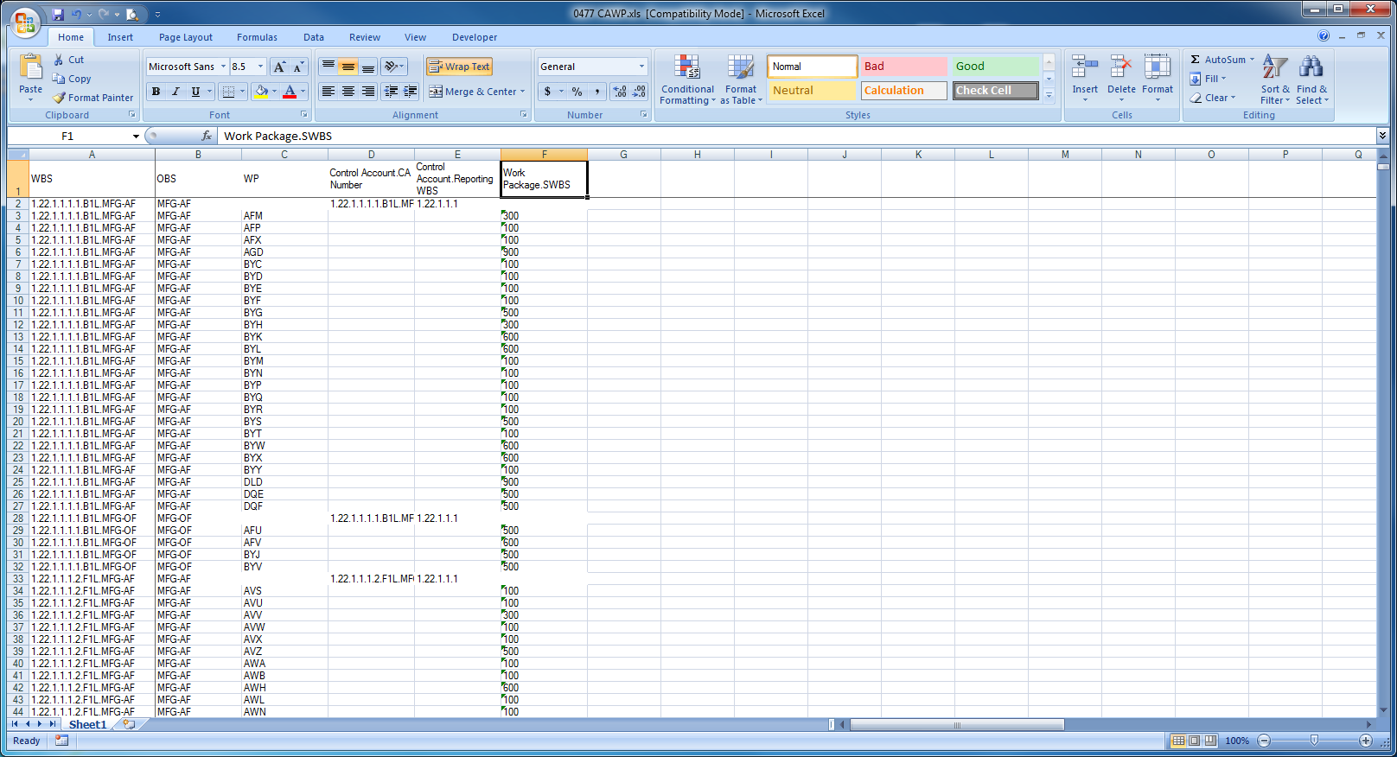

1. Turn on filters. Click the filter in the WP column and select only Blanks.
2. Click the filter in the Control Account.CA Number column and select only blanks. These are the control accounts that need a CA Number code. Copy the WBS to the Control Account.CA Number for each one that needs it. Click the filter in the Control Account.CA column and Select All.
3. Click the filter in the Control Account.Reporting WBS column and select only blanks. These are the control accounts that need the Reporting WBS. Enter the Control Account.Reporting WBS for each one that needs it. Click the filter in the Control Account.Reporting WBS and Select All.
4. Click the filter in the WP column select everything **BUT** blanks. Click the filter in the Work Package.SWBS column and select only blanks. These are WPs that need a SWBS code. Enter the appropriate SWBS code for each WP that needs it. Click the filter in the Work Package.SWBS column and Select All.
5. Save and close the file.
6. In Cobra start the Integration Wizard. Select the radio button for **Project data**. Click Next.
7. Select the radio button to **Open an Existing Configuration**. Click the ellipsis, navigate to and select you project’s integration file for loading **Codes Not From P6**. Click Next.
8. On the Action Selection screen, select the box in Project Data for **Code Assignments**. Click Next.

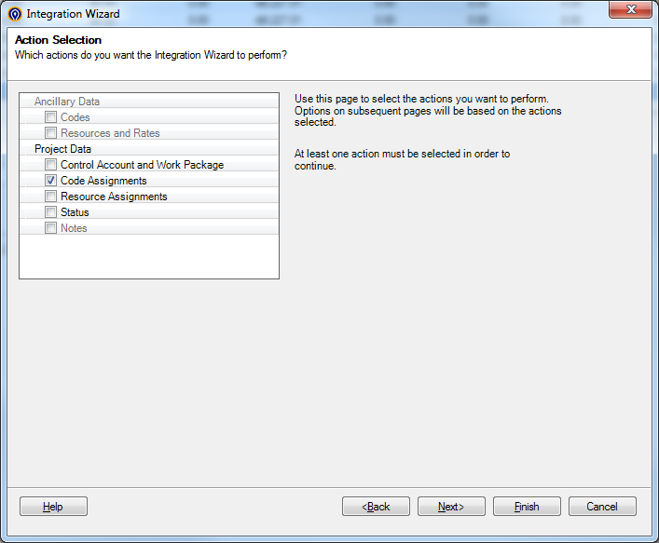

1. On the Project Selection screen, click the ellipsis for **Activity File**. Navigate to and select the load file you prepared. Click the ellipsis for **Cobra Project**. Navigate to and select your project. Click Next.
2. The Activity File Field Mapper is a screen that shows how Cobra is interpreting your load file. The columns here should match the columns in your load file. Click Next.

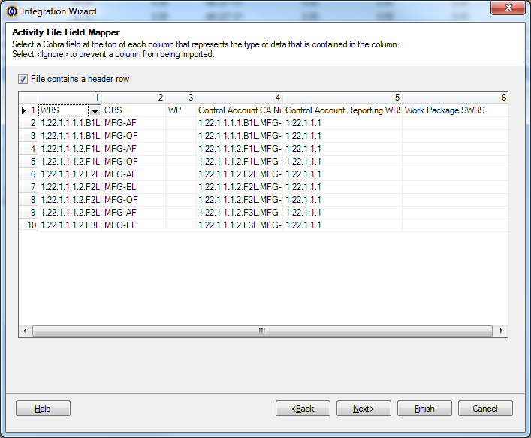

1. On the Filter screen, click the dropdown and select **Total Project.** Nothing else should be checked on this screen. Click Next.
2. Save the configuration if you wish, otherwise click Finish.